Mobile App Readme

**Visual Studio Code 🡪 File 🡪 open**

1. Use powershell : npm install –global yarn
2. use Git Base
3. yarn
4. cd android
5. Setup Environment JAVA_HOME : C:\Program Files\Java\jdk1.8.0_291
6. ./gradlew assembleDebug /* this is for Debug Mode apk */
7. ./gradlew assembleRelease /* this is for app apk */

**Android Studio**

I used version : android-studio-ide-202.7486908-windows

1. Setup for Android Studio :

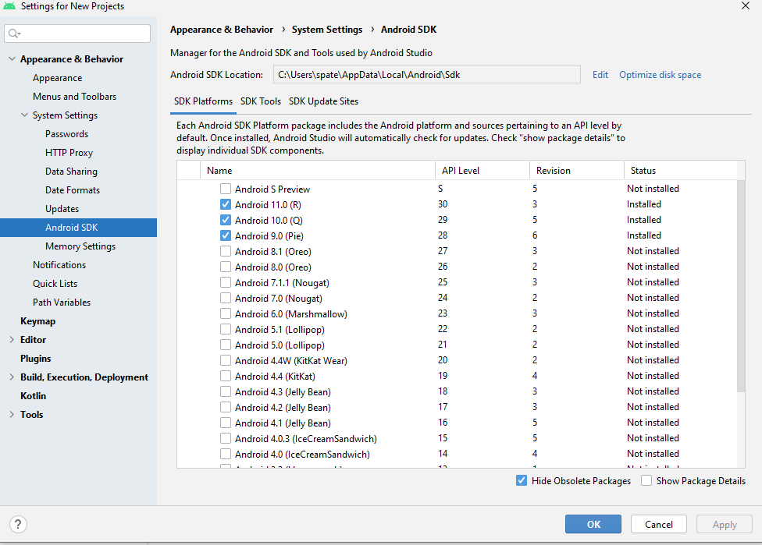

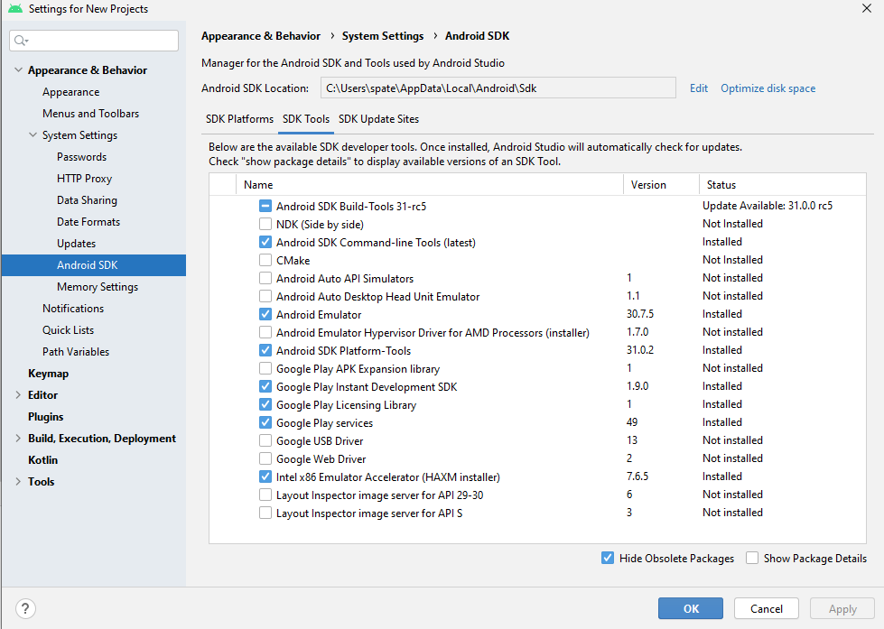

1. Once installed done.
2. File 🡪 Open 🡪 C:\Projects\eclub_rn-master\android
3. Click OK it will load .
4. Run 🡪 Debug ‘app’
5. Build Successfully

**Go Back to Visual Studio Code**

1. **Git base terminal : yarn start**

**Run On android Device :**

Copy: app-release.apk

from : C:\Projects\eclub_rn-master\android\app\build\outputs\apk\release\

Connect android Device thru USB

Click Allow

Paste File: This PC\Galaxy A32 5G\Phone\Download

Search for download folder on Device 🡪 click app-release.apk 🡪Install